### **Prerequisites**

Before proceeding, ensure you have the following:

* MobaXterm installed on your Windows machine. If you don't have MobaXterm, you can download it from the official website: [MobaXterm](https://mobaxterm.mobatek.net/).
* The IP address of the Ubuntu server you wish to connect to.
* The private key file (.pem or .ppk format) provided for the connection. This key is essential for a secure connection to your server without a password.

### **Steps to Connect to an Ubuntu Server Using MobaXterm**

#### Step 1: Launch MobaXterm

* Open MobaXterm on your Windows machine by clicking on its icon.
* Once open, you will see the MobaXterm dashboard.

#### Step 2: Start a New SSH Session

* In the MobaXterm dashboard, click on the "Session" button at the top left corner.
* A new window will appear. Select "SSH" from the list of session types.

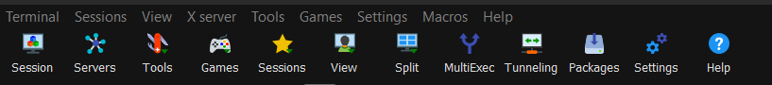

#### Step 3: Configure SSH Session

* In the "Remote host" field, enter the IP address of your Ubuntu server.
* Ensure the "Specify username" option is checked and enter your username for the Ubuntu server.
* Leave the "Port" field as the default (22) unless you were given a different port to use.

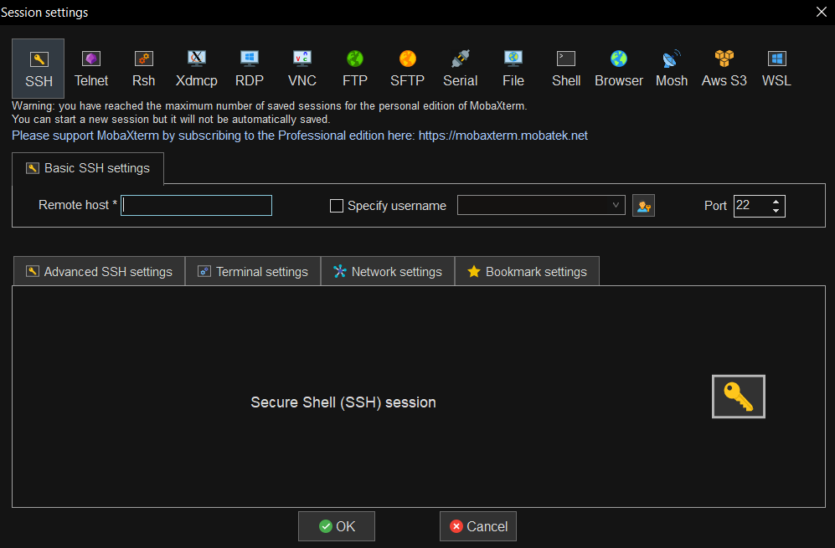

#### Step 4: Setting up the Private Key

* In the same SSH session window, navigate to the "Advanced SSH settings" tab.
* Check the "Use private key" option.

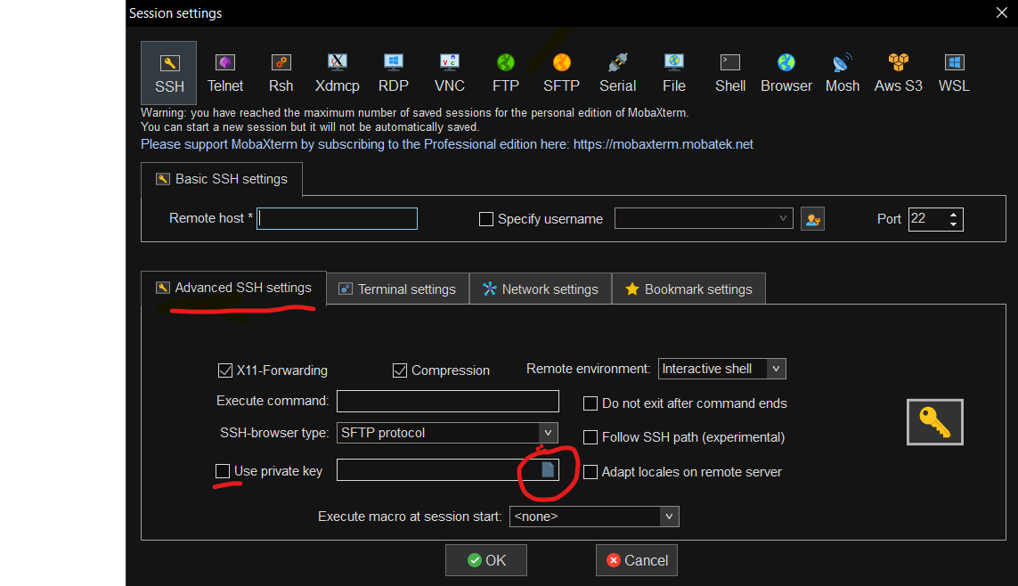

* Click on the folder icon next to the "Use private key" checkbox to browse and select your provided key file (.pem or .ppk format).

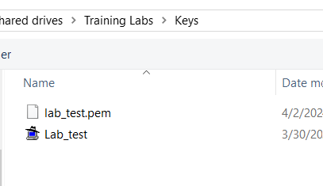

#### Step 5: Saving and Opening the Session

* Optionally, you can save this session for future use by entering a name for it in the "Bookmark settings" section at the bottom and clicking the "Save" button.
* Click on the "OK" button to initiate the connection.
* If this is the first time you are connecting to this server, you may receive a security alert asking you to confirm the server's host key. Click "Yes" to continue.

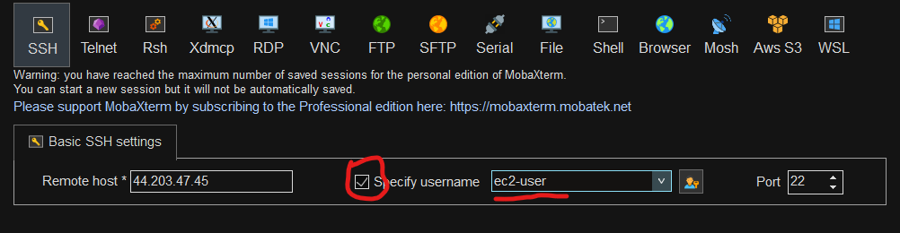

#### Step 6: Successful Connection

* If all the details were correct, you will be connected to your Ubuntu server's command line interface.
* You can now start executing commands on the server as required.

### **Additional Tips**

* Ensure your key file permissions are set correctly; it should not be publicly viewable. You can set the appropriate permissions using the file properties in Windows.
* If you encounter any errors during the connection, double-check the IP address, username, and ensure your key file is correct and not corrupted.
* For enhanced security, it's advised to update your server's packages and change the default SSH port (if allowed).